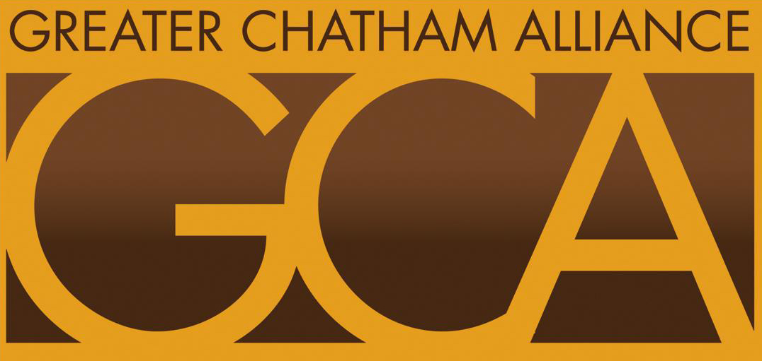
GREATER CHATHAM ALLIANCE (GCA)
Candidate Nomination Form
PLEASE WRITE THE NAME AND EMAIL ADDRESS ON THE LINE OPPOSITE POSITION THE CANDIDATE IS RUNNING FOR:
Please Print CANDIDATE’S NAME

PRESIDENT: __________________________________________________________
ADDRESS & PHONE NUMBER ___________________________________________

VICE- PRESIDENT: _____________________________________________________
ADDRESS & PHONE NUMBER ___________________________________________

CORRESPONDING SECRETARY: ________________________________________
ADDRESS & PHONE NUMBER ___________________________________________

TREASURER: __________________________________________________________
ADDRESS AND PHONE NUMBER _______________________________________

OPTIONAL ––Please Print – NOMINATING PARTY’S NAME
NAME___________________________________________________________
PHONE___________________________________________________________

ALL FORMS MUST BE SUBMITTED BY 5:00 PM MONDAY OCTOBER 9, via website OR EMAIL TO LUTHER AT: LUFTECH@AMERITECH.NET

