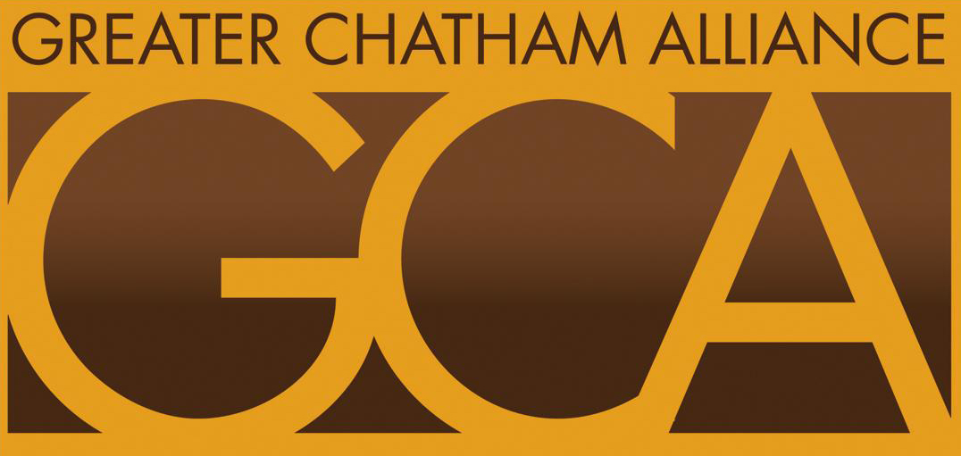
GREATER CHATHAM ALLIANCE (GCA)
Candidate Nomination Form
PLEASE CHECK THE G.C.A. OFFICE THE CANDIDATE IS RUNNING FOR:

PRESIDENT VIC E- PRESIDENT
CORRESPONDING SECRETARY TREASURER
RECORDING SECRETARY

Please Print CANDIDATE’S NAME
NAME___________________________________________________________ ADDRESS________________________________________________________
PHONE___________________________________________________________
E-MAIL_________________________________________________

OPTIONAL ––Please Print – NOMINATING PARTY’S NAME
NAME___________________________________________________________
PHONE___________________________________________________________
E-MAIL ADDRESS ( Optional)________________________________________________

ALL FORMS CAN BE SUBMITTED AT OUR MEETING
ON : September 16 or via website

CONTACT LUTHER if any questions Email: luftech@ameritech.net

